df1.head(5)

|  |  |  |  |  |  |  |  |  |  |
| --- | --- | --- | --- | --- | --- | --- | --- | --- | --- |
|  | **Serial No.** | **GRE Score** | **TOEFL Score** | **University Rating** | **SOP** | **LOR** | **CGPA** | **Research** | **Chance of Admit** |
| **0** | 1 | 337 | 118 | 4 | 4.5 | 4.5 | 9.65 | 1 | 0.92 |
| **1** | 2 | 324 | 107 | 4 | 4.0 | 4.5 | 8.87 | 1 | 0.76 |
| **2** | 3 | 316 | 104 | 3 | 3.0 | 3.5 | 8.00 | 1 | 0.72 |
| **3** | 4 | 322 | 110 | 3 | 3.5 | 2.5 | 8.67 | 1 | 0.80 |
| **4** | 5 | 314 | 103 | 2 | 2.0 | 3.0 | 8.21 | 0 | 0.65 |

plotCorrelationMatrix(df1, 8)

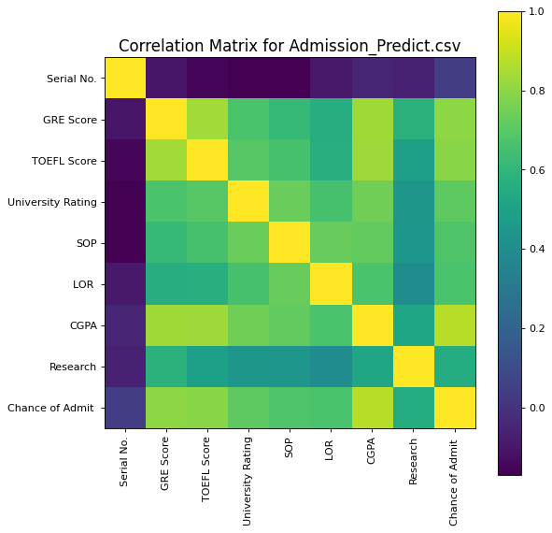

plotScatterMatrix(df1, 20, 10)

